Regional Variations of Sustainable Winegrowers in Australia

Have a quick search for “notabley” and “with x” to re write these. Notably is ok but only if it is actually something worth noting!

Introduction

Answer the following within the introduction:
- Why Sustainable Winegrowing?
- - Why is it hard?
- Data can inform xyz, but mostly idea, because [reason]
- Data approaches have been done in SA and World
- Gap left
- Here we fill these gaps by

Broad problem
· Highlight of specific gap in literature
· What has been done before
· Hint at the broad approaches needed to tackle the gap (maybe x2 parags)
· Clear “here we will fill this gap by….” Paragraph telegraphing the approach and findings
Abbal et al. Goes into detail as to why the location of a vineyard is important and what it influences.
You have several references to do with predicting yield for vineyards and agricultural in a broader sense. Talk about how this relates to regional differences as well as introduce why you are using this metric.

The Australian wine-growing industry is a rich and diverse landscape that is separated into multiple regions that help to describe the unique varietals and qualities that are produced there. Each region is known as a Geographical Indicator Region (GI Region) and has its own unique mixture of climatic and geophysical properties (Halliday, 2009; Oliver et al., 2013; SOAR et al., 2008); with each region being explicitly defined under Wine Australia Corporation Act 1980 (Attorney-General’s Department, 2010). Many of the geophysical properties of a GI Region contribute to the determination of the quality and quantity of grapes produced within it. As a result, the average rate paid for grapes varies significantly between these regions, more so than between specific vineyards (Wine Australia, 2022).

While a great deal has been done to describe regional characteristic differences, properties and traits, there has been little statistical insight into these differences due to a lack of long-term and in-depth data sources (Keith Jones, 2002; Knight et al., 2019). In this study we use General Linear Models (GLMs) and Classification Trees at what baselines can be established to compare these regions and how they differ from one another.

Investigate the potential to characterise the regions using data

Methods

Data
What region?

The data used in this analysis was extracted from Sustainable Winegrowing Australia. The dataset initially contained 6047 samples collected for each season from 2012 to 2022, with each sample containing financial and physical data of a vineyard for its recorded season. The variables used for this study were fuel emissions, total water use use, fertiliser applied, yield and area; with water and fertiliser being calculated as sums of all water and fertiliser sources for any given vineyard, and emissions being calculated from diesel, petrol, biodiesel, LPG and electricity sourced from the grid. Emissions were calculated from fuels and electricity use into tonnes of CO2 using the Australian National Greenhouse Accounts Factors (Department of Climate Change, Energy, the Environment and Water, 2022).

Equation 1: show the equation from ANGAF

The dataset was cleaned as to only include samples who had recorded values for size, yield, water use and fuel use to allow the comparison of continuous variables between samples in this study. Site size was also limited to vineyards that were over 1000m2 and had a recorded site location. 30 values were removed from contractor due to containing decimal values within discrete fields, and 2 further values were removed from the average sale price per tonne for recording the sale price as $1.

Of these samples there were 1298 separate sites sampled over the 10 year recording period.

The data used in this analysis was extracted from Sustainable Winegrowing Australia and covers the period 2012 to 2022. Data sourcing and operations were conducted in the Python programming language (G. van Rossum, 1995) using the rpy2 package (rpy2 foundation, 2022) to connect data sources to R based models. It contained data from 6091 sites across 58 GI Regions, with 76 degrees of freedom.

Many variables were sparse due to their optional recording, to reduce the effects of sparsity and dimensionality, 15 summary variables were created by amalgamating other variables. The summary variables were chosen due to their high response rates. The data was limited to sites that had responded to area, yield, water, fuel and energy use. Fuel and energy use were combined into a total emissions variable, derived from scope 1 and 2 emissions, this was comprised of petrol, diesel, bio-fuel and electricity used for vehicles and irrigation. Emissions were calculated using the Australian National Greenhouse Accounts Factors (Department of Climate Change, Energy, the Environment and Water, 2022).

There was a clear bias towards smaller vineyards due to their greater numbers within the industry. The minimum size is 1 hectare and the maximum was 2436.15, with a median of 27.9 and standard deviation of ~141. We wished to compare compare vineyards of different sizes effectively . To over come this the continuous variables were transformed by dividing the area and taking the logarithm. After the transformation we were able to compare...

This also helped in the recognition of radical values within the data. The found radicals were values likely caused by entry and unit errors and were removed by culling the top and bottom 0.5% of logarithmic transforms for total water, yield, electricity and fuel as ratios to area; removing an overall 4% of the data. All together the process resulted in a population sample size of 5189 sites over 56 GI Regions. Notably the number of respondents varied greatly between regions with a range from 1 to 977, a median of 22, and standard deviation of ~173.

Generalised Linear Model (GLM)
GLM models were created in the R statistical programming language (R Core Team, 2021). Several iterations of GLMs were created to compare model performance and select for levels of complexity. This iterative process was used to select intuitive dependent variables and significant predictors, resulting in the focus of modelling two response variables. The first used to illustrate a measure of productivity by utilising tonnes of grapes harvested per hectare. The second model built on this by incorporating the average price of grapes per tonne to create a measure that compared market performance between low and high grape qualities. For the second model the dataset was condensed down to sites that had recorded financial data regarding their crops. This meant an initial sample size of 1036, which was bolstered by using the regional average prices from Wine Australia (Wine Australia, 2022, 2021, 2020, 2019; Winemakers’ Federation of Australia, 2018, 2017, 2016, 2015, 2014, 2013, 2013) where appropriate, increasing the number of records to 3342.

Results
Data Exploration

Put in a table regarding the site and variable response rates.

Put in your correlation table, do this for the transformed data

Most variables were heavily skewed towards lower values due to the numerous smaller vineyards. A log transform assisted in tempering this skew as shown in Figure 1 compared to Figure 2.

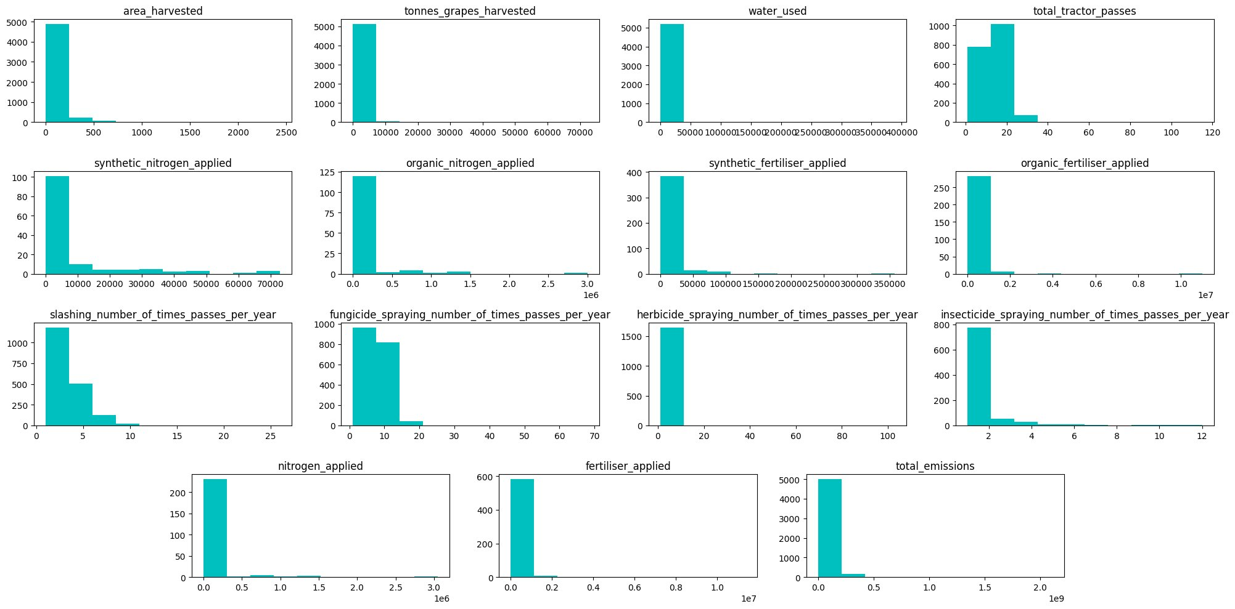
Figure 1: A histogram of raw data values for the summary variables.

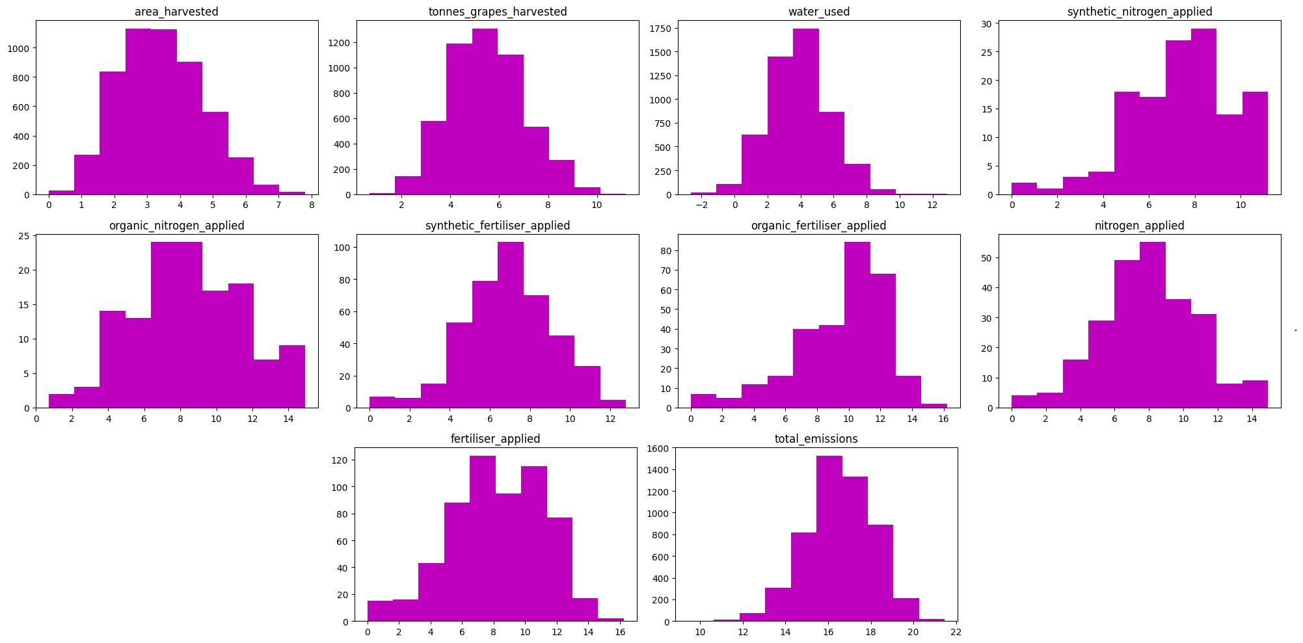
Figure 2: A histogram of log transformed values for the continuous summary variables.

To further assist in creating a linear model, variables were also divided by vineyard area to describe their productivity. The effect of both the log transformation and normalisation by area is visible when comparing the non-linear masses in Figure 3 compared to the potentially linear patterns in Figure 4.

GLMS
The first GLM was used to determine variables that contributed the most to prediction (Table 1). The contribution of fertiliser applied only resulted in an Akaike Information Criterion (AIC) of -712.15 compared with the final model’s score of -679.25. The summary of the final model that used only emissions and water is shown in Table 2. The residuals of the final model were approximately normal (Figures 4 and 5). The model had difficulty determining the values of larger and smaller yields per hectare (Figure 6 ); which was also visible by the curvature for larger values, and the line formation below the central mass. The difficulty in predicting particularly high and low values for productivity was also illustrated with long skewed tails on the histogram and deviations at the tail ends of the QQ-plot in Figure 3 and 4 respectively.
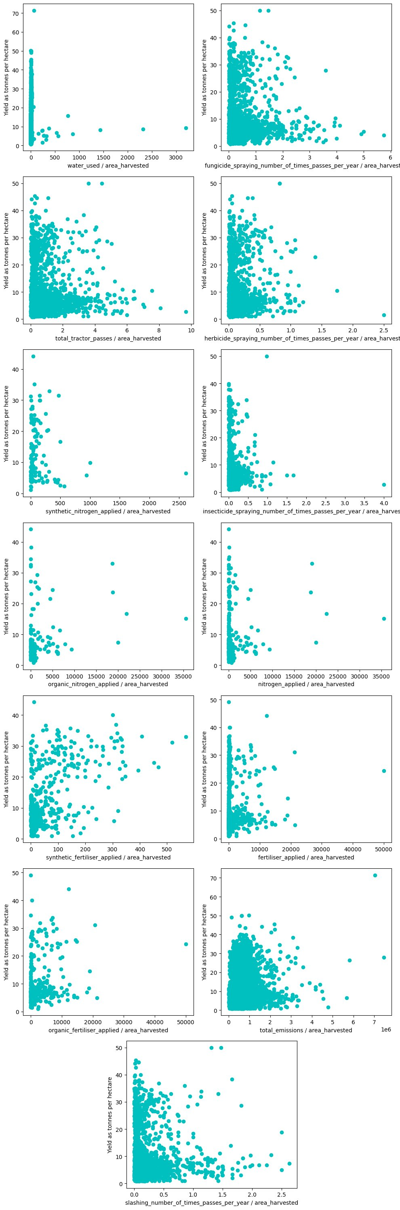
Figure 3: Shows the relationship between summary variables per hectare on the x-axis and yield in tonnes of grapes per hectare on the y-axis.

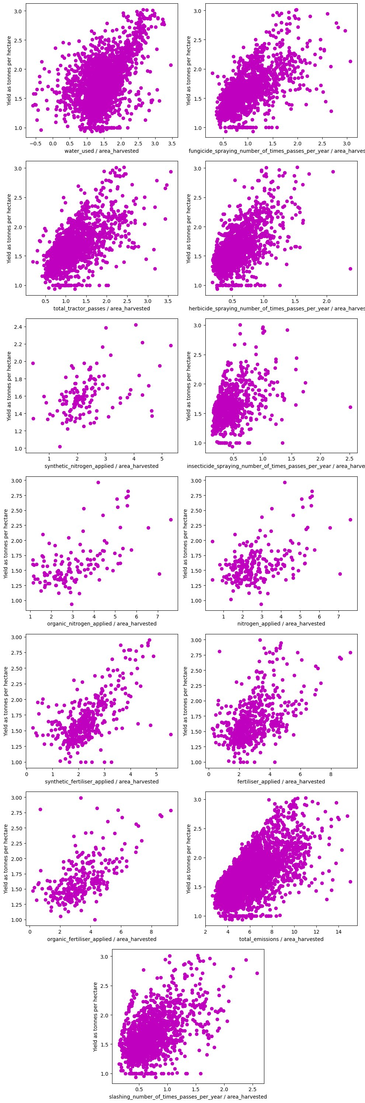
Figure 4: Shows the relationship between the log transform of continuous summary variables per hectare on the x-axis and the log transform of the yield in tonnes of grapes per hectare on the y-axis.
Variable | Pr(>|t|) | T-value | Std. Error | Estimate
(Intercept) | <2e-16 | 17.5 | 0.06 | 1.13
log total emissions | <2e-16 | 16.8 | 0.01 | 0.09
log water used | 0.73 | -0.35 | 0.01 | 0
total tractor passes | 0.52 | -0.64 | 0.1 | -0.07
log synthetic nitrogen applied | 0.4 | -0.85 | 0.02 | -0.02
log organic nitrogen applied | 0.65 | 0.46 | 0.03 | 0.01
log synthetic fertiliser applied | 0.67 | 0.43 | 0.01 | 0.01
log organic fertiliser applied | 0.13 | -1.51 | 0.01 | -0.02
slashing number of times passes per year | 0.56 | 0.59 | 0.1 | 0.06
fungicide spraying number of times passes per year | 0.52 | 0.65 | 0.1 | 0.07
herbicide spraying number of times passes per year | 0.49 | 0.69 | 0.1 | 0.07
insecticide spraying number of times passes per year | 0.61 | 0.51 | 0.1 | 0.05
log nitrogen applied | 0.65 | -0.45 | 0.03 | -0.01
log fertiliser applied | 0.05 | 1.98 | 0.01 | 0.03
log total emissions / log area harvested | <2e-16 | -38.8 | 0 | -0.02
log area harvested / log water used | <2e-16 | 17.2 | 0 | 0.03
log area harvested / log synthetic nitrogen applied | 0.21 | 1.26 | 0.01 | 0.01
log area harvested / log organic nitrogen applied | 0.73 | -0.34 | 0.01 | 0
log area harvested / log synthetic fertiliser applied | 0.66 | 0.45 | 0 | 0
log area harvested / log organic fertiliser applied | 0.07 | 1.82 | 0 | 0

Table 1: The corresponding test values and estimates of the first GLM using all variables.

Variable | Estimate | Std. Error | T-value | Pr>|t|
Intercept | 1.13 | 0.06 | 17.63 | <2.00E-16
log total emissions | 0.09 | 0.01 | 16.67 | <2.00E-16
log water used | 0 | 0.01 | 0.31 | 0.75
log fertiliser applied | 0 | 0 | 3.61 | 0
log total emissions / log area harvested | -0.02 | 0 | -38.97 | <2.00E-16
log area harvested / log water used | 0.03 | 0 | 17.08 | <2.00E-16

Table 2: The corresponding test values and estimates of the final GLM model for predicting yield per area.

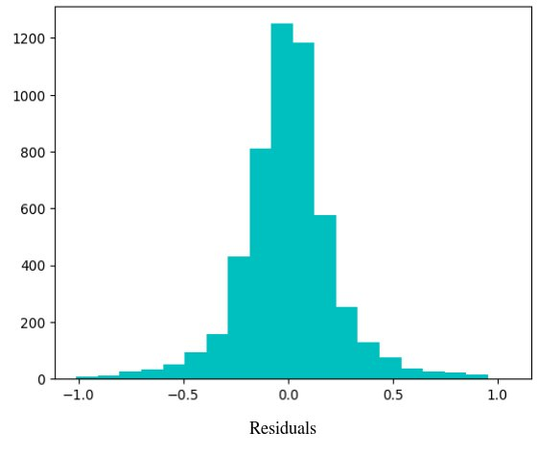

Figure 5: A histogram of the residuals for the final GLM model used to predict tonnes of grapes harvested per hectare, as depicted in Table 2.
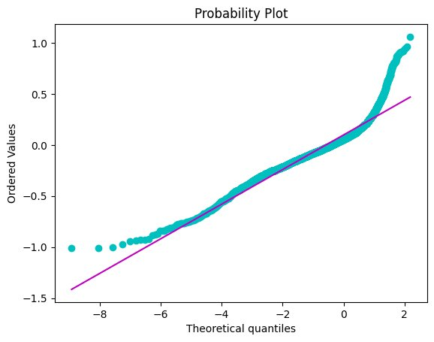
Figure 6: A QQ-plot comparing the residuals of the final GLM model used to predict tonnes of grapes harvested per hectare, as depicted in Table 2, to theoretically normal values.

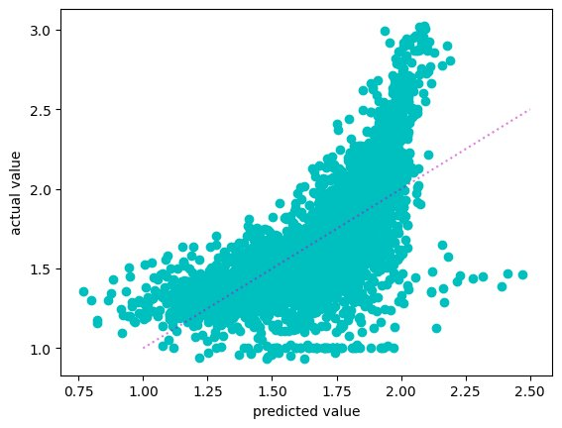
Figure 7: The actual values for yield per hectare on the y-axis vs the predicted values of the GLM on the x-axis using the model summarised in Table 2.

Both GLM models found that the model of greatest accuracy using fewest variables was parameterised by total emissions and total water, as shown in Table 3. The second GLM showed lower standard errors when using these variables as predictors. The second model also presented similar traits to the first, as expected due to its response variable being a linear transformation of the first models, see Equation 1 and Equation 2. Again, the residuals appear normal as shown in Figure 7 and 8 with the same issues arising around predictions of particularly low and high values. The issue around the tail ends is very pronounced when reviewing the predicted verses the actual values, where they follow a reasonably linear trend with a slight bend present, see Figure 9

Equation 1: The proposed GLM model for tonnes per hectare.

Equation 1: The proposed GLM model for value per hectare.

Variable | Estimate | Std. Error | T-value | Pr(>|t|)
Intercept | 5.55 | 0.18 | 30.17 | <2e-16
log total emissions | 0.24 | 0.02 | 15.93 | <2e-16
log water used | -0.77 | 0.02 | -40.28 | <2e-16
log total emissions / log area harvested | -0.1 | 0 | -55.4 | <2e-16
log area harvested / log water used | 0.2 | 0 | 43.64 | <2e-16
Table 3: The corresponding test values and estimates of the GLM model for value.

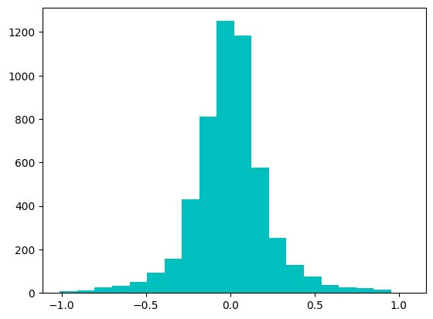
Figure 8: A histogram of the residuals for the final GLM model used to predict tonnes of grapes harvested per hectare, as depicted in Table 2.
Figure 9: A QQ-plot comparing the residuals of the final GLM model used to predict tonnes of grapes harvested per hectare, as depicted in Table 2, to theoretically normal values.

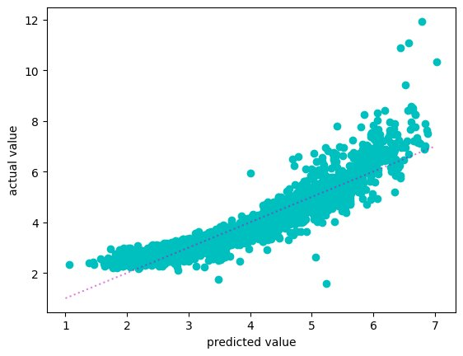
Figure 10: The actual values for yield per hectare on the y-axis vs the predicted values of the GLM on the x-axis using the model summarised in Table 2.

The results from the GLM models were used to compare 16 of the most prolific regions by highlighting the sites of a given region against the rest of the population sample (Figure 10). This illustrated a clear difference in levels of production between certain regions, particularly those inland such as the Murray Darling, Riverland and Swan Hill, compared to coastal regions. The relationship between productivity and water plus emissions showed the inland regions following along the top of the trend, whereas when the average cost of grapes was included, this relationship was reversed placing the warm in land regions along the bottom of the trends.
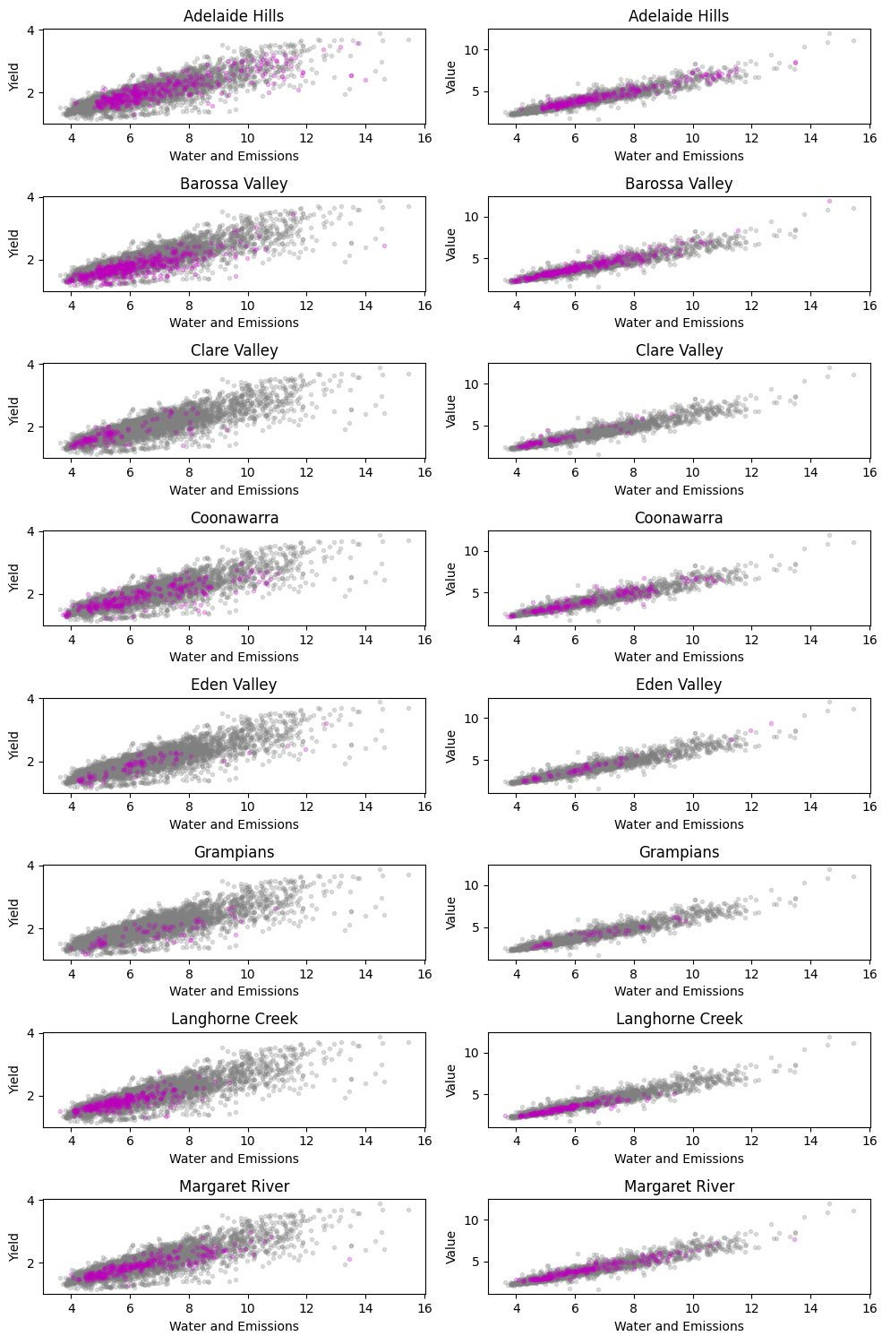
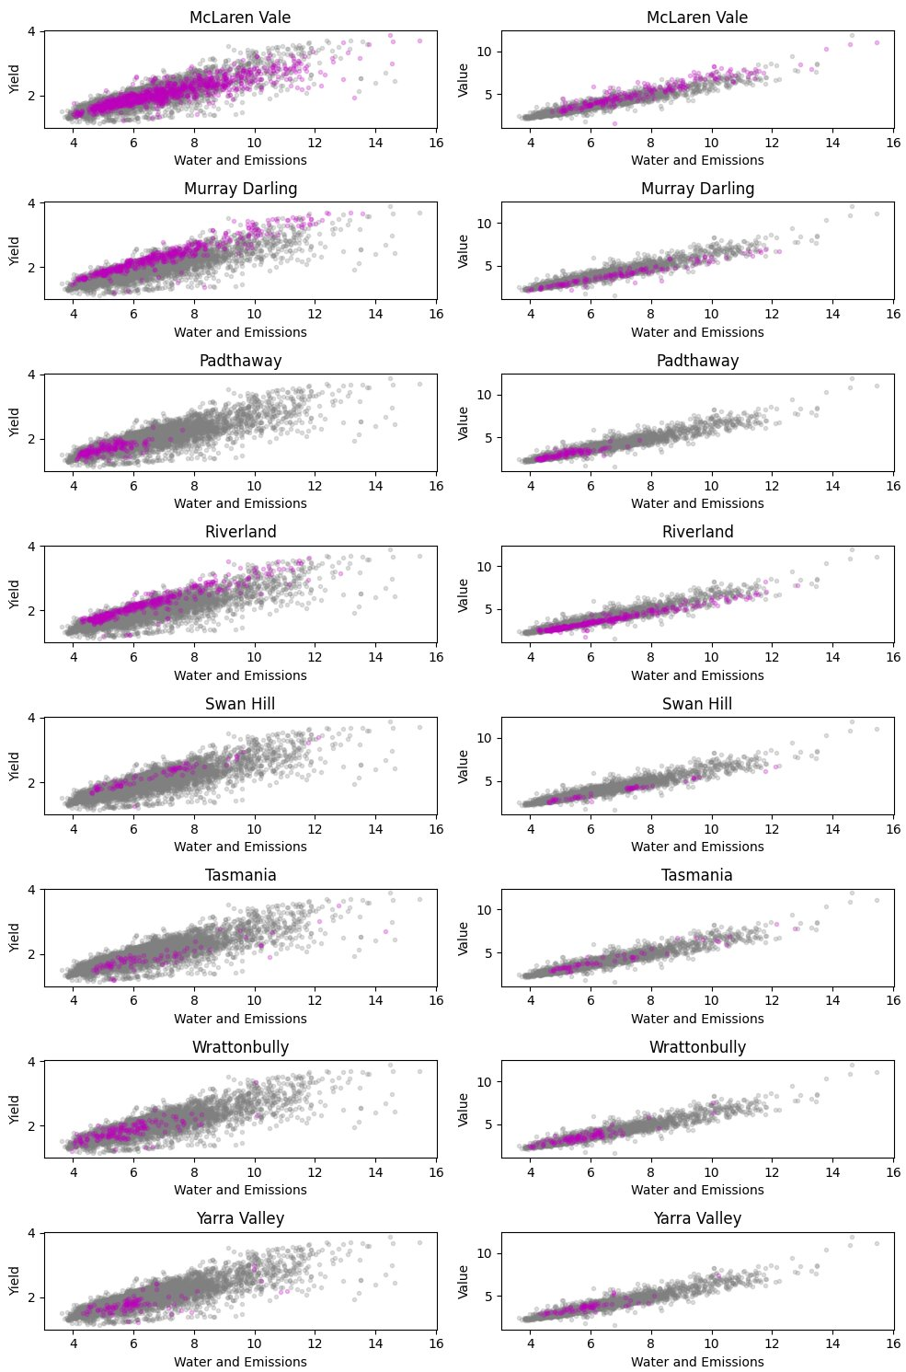
Figure 11: The 16 most prominent regions, with at least 50 entries. The left side y-axis depicts the productivity as yield per hectare, and the right productivity multiplied by the average sale price. The sum of total emissions and water use is on the x-axis.
Discussion
The results of this study have shown that there is a strong linear relationship between yield and the consumption of energy and water in vineyards. This relationship still persists when considering the average sale price of tonnes yielded. However, Figure 11 indicates the residuals are not transformed in the same linear manner as the response variable for each GI region; showing that there is a complex non-linear interaction between value and yield. The difference between crop values and yield is most notable for the warm inland regions such as the Riverland, Murray Darling and Swan Hill, changing from being top producers to being on the bottom when sales prices are included.

The inclusion of price is only described by a singular variable within this study. However in reality it is governed by complex forces such as international market demands, COVID-19, disease pressures and natural disasters, as highlighted throughout the past decades vintage reports; it is also important to consider that these reports show that the warm inland regions have seen a decline in profit during this period (Wine Australia, 2022, 2021, 2020, 2019; Winemakers’ Federation of Australia, 2018, 2017, 2016, 2015, 2014, 2013, 2012).

Even given the issues faced in the past decade the relationships were very strong showing low variance within the residuals, especially upon the incorporation of average sales price. Linear relationships allow a certain level of understanding for how much investment may be required for a vineyard of a given size, helping to establish lower and upper bounds for performance given reasonably normal operating parameters; however it is very difficult to untangle the contributing factors to the success of winegrowers as these investments do not include the when, how and why of these costs (Leilei He et al., 2022).

Literature shows that there are many complex decisions to be made on the ground depending on many compounding factors that influence both quality and yield ((Abad et al., 2021; Cortez et al., 2009; Hall et al., 2011; I. Goodwin, et al., 2009; Kasimati et al., 2022; Oliver et al., 2013; Srivastava and Sadistap, 2018)). There are also differences when comparing winegrowers to other agricultural industries as they are vertically integrated within the wine industry, tying them to secondary and tertiary industries, such as wine production, packaging, transport and sales. This results in unique issues, where on-the-ground choices are influenced by other wine industry’s decisions, such as the use of sustainable practices in vineyards to sell in overseas markets; notably these interactions are further complicated by some winegrowers being totally integrated into wine companies, while others are not (Knight et al., 2019). It is incredibly difficult to attribute these outcomes to crop yields, the appendix further highlights the complexity of these relationships, where it is almost impossible to determine a linear relationship between those who use renewable energy or contractors and their yield versus emissions and water use.

The main limitations of the model include the difficulty in attributing outcomes to specific practices and the influence of other factors such as international pressures. The results suggest that further research is needed to fully understand the complexity of these relationships and how different practices and investments can influence the industry. The study highlights the importance of considering the holistic picture of the wine industry when attempting to determine the best courses of action; where it would be beneficial to conduct further research into how the operational decisions effect grape prices, yield and operational costs. The uncovering of contributions to classes such as those who use renewable energy or contractors would be a useful contribution in describing the nuances surrounding operational decisions and their outcomes.

References

Abad, J., Hermoso de Mendoza, I., Marín, D., Orcaray, L., Santesteban, L.G., 2021. Cover crops in viticulture. A systematic review (1): <br>Implications on soil characteristics and biodiversity in vineyard. OENO One 55, 295–312. https://doi.org/10.20870/oeno-one.2021.55.1.3599
Attorney-General’s Department, 2010. Wine Australia Corporation Act 1980.
Cortez, P., Teixeira, J., Cerdeira, A., Almeida, F., Matos, T., Reis, J., 2009. Using data mining for wine quality assessment, in: Discovery Science: 12th International Conference, DS 2009, Porto, Portugal, October 3-5, 2009 12. Springer, pp. 66–79.
Department of Climate Change, Energy, the Environment and Water, 2022. Australian National Greenhouse Accounts Factors.
G. van Rossum, 1995. Python tutorial, Technical Report CS-R9526.
Hall, A., Lamb, D.W., Holzapfel, B.P., Louis, J.P., 2011. Within-season temporal variation in correlations between vineyard canopy and winegrape composition and yield. Precis. Agric. 12, 103–117.
Halliday, J.C. (James C.), 2009. Australian Wine Encyclopedia. Hardie Grant Books, VIC.
I. Goodwin, L. McClymont, D. Lanyon, A. Zerihun, J. Hornbuckle, M. Gibberd, D. Mowat, D. Smith, M. Barnes, R. Correll, 2009. Managing soil and water to target quality and reduce environmental impact.
Kasimati, A., Espejo-García, B., Darra, N., Fountas, S., 2022. Predicting Grape Sugar Content under Quality Attributes Using Normalized Difference Vegetation Index Data and Automated Machine Learning. Sensors 22. https://doi.org/10.3390/s22093249
Keith Jones, 2002. Australian Wine Industry Environment Strategy.
Knight, H., Megicks, P., Agarwal, S., Leenders, M.A.A.M., 2019. Firm resources and the development of environmental sustainability among small and medium-sized enterprises: Evidence from the Australian wine industry. Bus. Strategy Environ. 28, 25–39. https://doi.org/10.1002/bse.2178
Leilei He, Wentai Fang, Guanao Zhao, Zhenchao Wu, Longsheng Fu, Rui Li, Yaqoob Majeed, Jaspreet Dhupia, 2022. Fruit yield prediction and estimation in orchards: A state-of-the-art comprehensive review for both direct and indirect methods. Computers and Electronics in Agriculture 195.
Oliver, D.P., Bramley, R.G.V., Riches, D., Porter, I., Edwards, J., 2013. Review: soil physical and chemical properties as indicators of soil quality in Australian viticulture. Aust. J. Grape Wine Res. 19, 129–139. https://doi.org/10.1111/ajgw.12016
R Core Team, 2021. R: A Language and Environment for Statistical Computing.
Reynolds, A.G., 2010. Managing Wine Quality : Viticulture and Wine Quality., Woodhead Publishing Series in Food Science, Technology and Nutrition ; v.1. Elsevier Science, Cambridge.
rpy2 foundation, 2022. rpy2.
SOAR, C.J., SADRAS, V.O., PETRIE, P.R., 2008. Climate drivers of red wine quality in four contrasting Australian wine regions. Aust. J. Grape Wine Res. 14, 78–90. https://doi.org/10.1111/j.1755-0238.2008.00011.x
Srivastava, S., Sadistap, S., 2018. Non-destructive sensing methods for quality assessment of on-tree fruits: a review. J. Food Meas. Charact. 12, 497–526.
Terry Therneau, Beth Atkinson, 2022. rpart: Recursive Partitioning and Regression Trees.
Wine Australia, 2022. National Vintage Report 2022.
Wine Australia, 2021. National Vintage Report 2021.
Wine Australia, 2020. National Vintage Report 2020.
Wine Australia, 2019. National Vintage Report 2019.
Winemakers’ Federation of Australia, 2018. National Vintage Report 2018.
Winemakers’ Federation of Australia, 2017. National Vintage Report 2017.
Winemakers’ Federation of Australia, 2016. National Vintage Report 2016.
Winemakers’ Federation of Australia, 2015. National Vintage Report 2015.
Winemakers’ Federation of Australia, 2014. National Vintage Report 2014.
Winemakers’ Federation of Australia, 2013. National Vintage Report 2013.
Winemakers’ Federation of Australia, 2012. National Vintage Report 2012.

Appendix A:

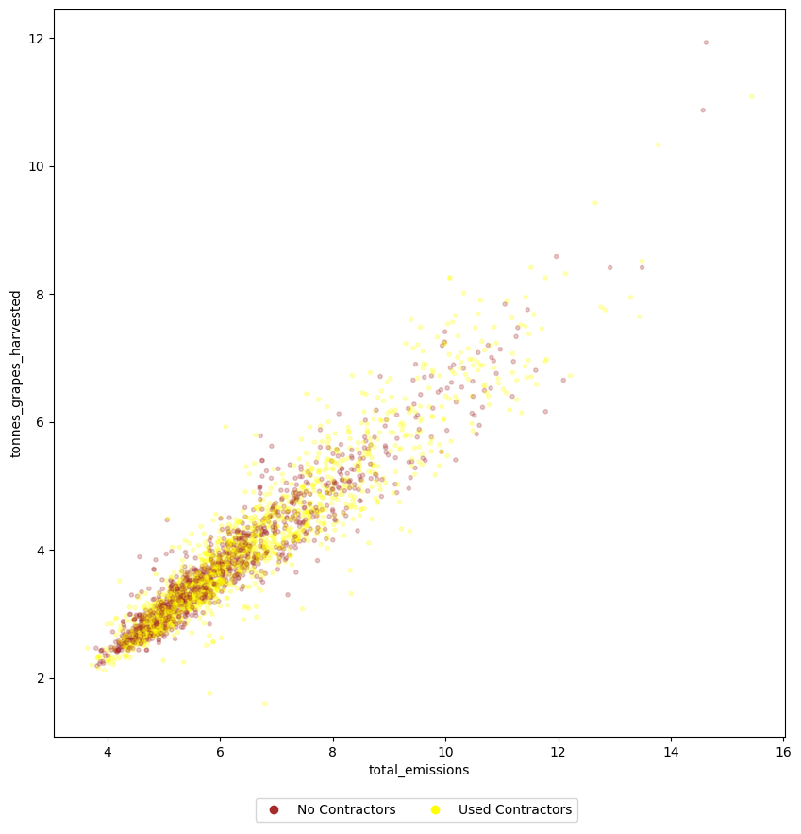

Sites that used contractors for slashing, spraying and weeding verse those that did not, for tonnes grapes harvested multiplied by average value verse total emissions and water use.
Appendix B:
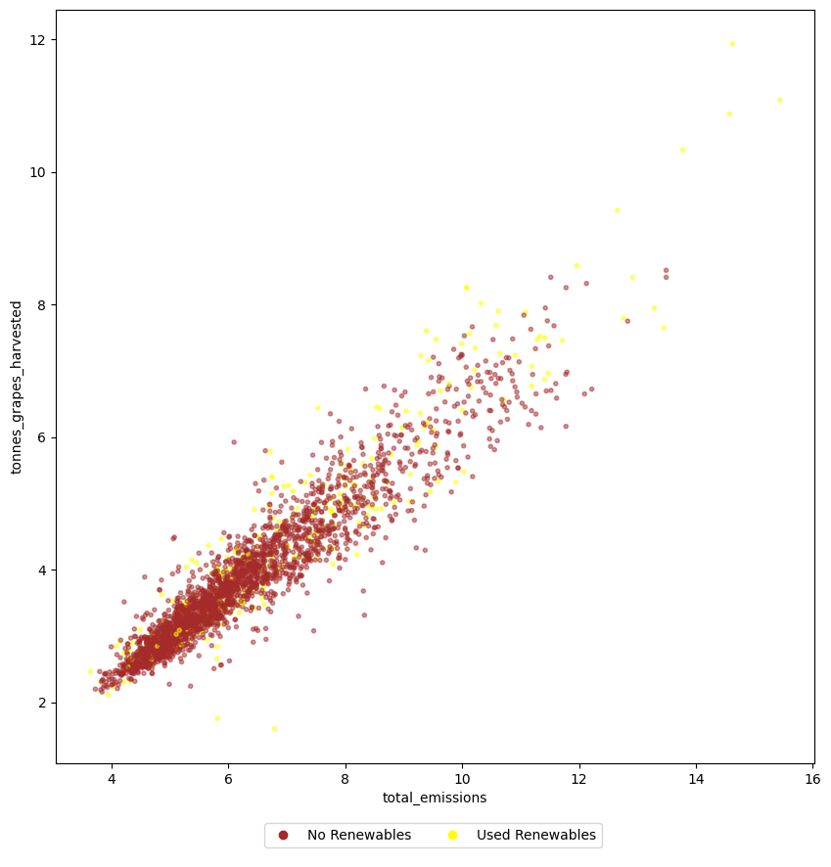
Sites that used renewable energy verse those that did not, for tonnes grapes harvested multiplied by average value verse total emissions and water use.

